Mr. Crowell
Freeport Area Middle School
Eighth Grade American History
crowell@freeport.k12.pa.us
www.ss213.weebly.com

Dear Eighth Grade Social Studies Student,

Welcome to social studies! Below is a description of some things that you can expect in social studies this school year. Please read and review this with your parents.

Course Description

In eighth grade social studies we will answer some essential questions about our nation such as:

- What was North America like before European presence?
- How have people struggled for equality in the United States?
- What ideas and events have led to conflict in the United States?
- How has conflict shaped and influenced United States History?
- How do ideas like democracy, capitalism, and liberty shape U.S. history and culture?

These questions and many more will be addressed throughout the year through the study these main topics.

-American Indian Culture and History
-European exploration, settlement, and colonization
-Slavery in the Americas
-The American Revolution
-The Constitution
-Early Presidents
-Transformative events and movements of the 1800’s
-The Civil War and Reconstruction
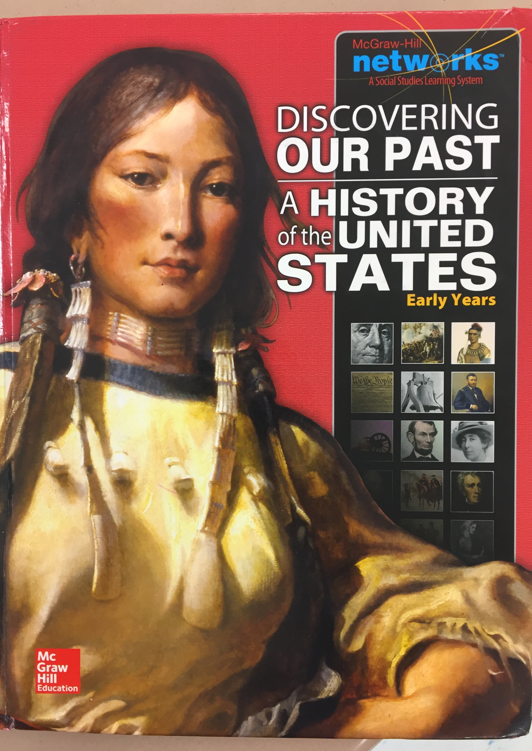
-Current events related to social studies content

Textbook

We will be using the Discovering Our Past: Early History of the United States text throughout the school
year. Students are expected to bring their text to class on a daily basis.

Class Website

My class website, www.ss213.weebly.com, can be found on the school’s list of teacher web pages. On this website a class calendar can be found along with resources for each chapter. At some point during the year students will create their own webpage as part of this site.

Rules and Discipline

Classroom rules

- Be Respectful
  - To classmates, adults and property
- Be Responsible
  - For your actions and learning
- Be Positive
  - By being ready to learn and go with the flow
- Be Prepared
  - By having homework, class materials, and following class procedures

Consequences

1st offense Verbal Warning

2nd offense Behavior Reflection
-Given to student at the time of behavior to be completed and signed by a parent. The reflection should be returned to Mr. Crowell the next day.

3th offense Office referral

Grading and Assignments

The marking period grade will be loosely determined using this breakdown.

Tests, Quizzes, and Projects approximately 70%
Homework and Class Work approximately 30%

*Class participation points may be awarded at different times throughout the school year
*Students will complete one project per marking period.
*Homework is graded on a completion basis unless notified by myself.
*Late homework will be accepted at 50% until the end of that chapter of study
*Late projects will be penalized 10% for each day late.
*Extra credit will be offered at times throughout the year and via the class twitter board.

After you have reviewed the syllabus please sign below. Also, parents please provide your email address below if you prefer to be contacted via email during the school year.

Sincerely,

Mr. Crowell

We have read and understand the rules and procedures and class outline

Parent Signature: _______________________________________________________________

Student Signature:______________________________________________________________

Parent email:

